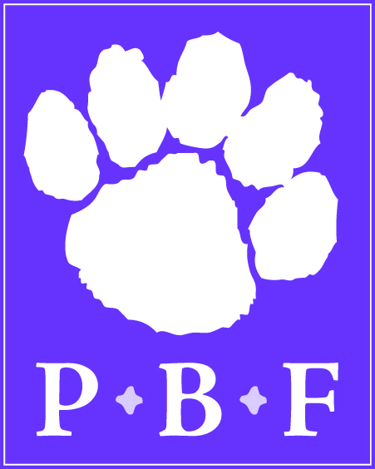

POLAR BEAR FOUNDATION
Profile of Board Members and Committee Members

Name | Crystal L. Hoffman
Township/Boro of residence | Carroll Township
Length of Service on the Board/Committee | New Member May 2016
Personal/Professional Background | B.A. in Education, Southeastern University  M.B.A, Penn State University  20+ years in non-profit accounting
How long have you lived in the district? | 20 years
Graduate of Northern? | No
Number of children currently in Northern district | 2
Number of children who graduated from Northern | 0
Favorite hobbies | Reading, hiking and family badminton competitions
What does serving on the Board/Committee mean to you? | I look forward to supporting and investing in the NYCSD in continuing to offer a quality education for years to come.

