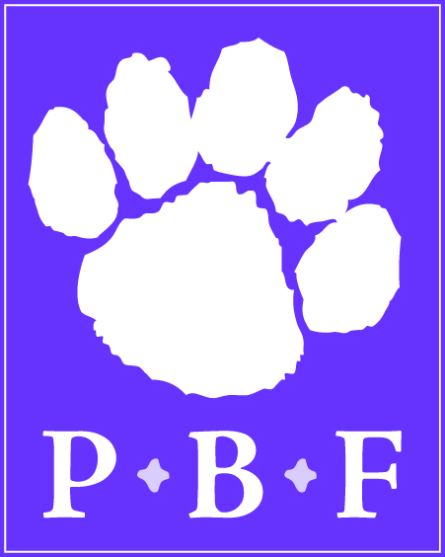

POLAR BEAR FOUNDATION
Profile of Board Members and Committee Members

Name | Gayle A. Yost
Township/Boro of residence | Monaghan Township
Length of Service on the Board/Committee | 4 years
Personal/Professional Background | My husband Richard and I have been married for 42 years. We have two children and five grandchildren. I am a graduate of Michigan State University and studied at La Universidad Ibéroamericana in Mexico City. I’ve done graduate work at Penn State, Temple and Lebanon Valley. I began teaching in 1969 in the Mechanicsburg Area School District. After some time off to have children, I returned to teaching in 1983 in the Northern District. I taught ESL in all district buildings, taught Spanish to 5th graders at all district elementary schools and began teaching Spanish at Northern High in 1988. In June 2010 I retired with 33 years of service.
How long have you lived in the district? | 42 years
Graduate of Northern? | No, but I am married to a Northern grad.
Number of children currently in Northern district | None
Number of children who graduated from Northern | Our son, Gregory M. Yost (1994) and our daughter Kristin A. (Yost) Bechtel (1996) are both Northern grads. Both are college graduates.
Favorite hobbies | Reading, gardening, traveling, and enjoying our five grandchildren.
What does serving on the Board/Committee mean to you? | I consider serving on the Polar Bear Foundation an honor. It is the perfect blend of my care and concern for Northern students and my continuing interest in the Northern York County School District Community.

